Main Title

[Main title style: *Arial*, size 14, bold, centered text, space after set to font size 10]

**First Author1*,** Second Author2 and Third Author2

[Author list style: *Arial*, font size 11, centered text, line spacing: single. Presenter in bold, co-authors separated by commas, and the last author preceded by "and" (without a comma). No initials or middle names]

1 Affiliation first author

2 Affiliation second author

[Institution list style: *Arial*, font size 10, italic, centered text, single line spacing]

*Corresponding Author: [xxx@yyy.com](mailto:xxx@yyy.com)

[Corresponding author’s email style: *Arial*, font size 10, centered text]

[Body text style: *Arial*, font size 11, justified alignment, single line spacing]

This document contains the instructions to prepare and submit your abstract for ECTP2026. The abstract should summarize the objectives, methodology, results, and conclusions of the work. Page format: A4 (210 × 297 mm); margins: 20 mm on all sides, except the top margin; the paper title should start 25 mm from the top of the page. Once finalized, the abstract must be converted to PDF format and uploaded via: <https://ectp2026.sciencesconf.org/>

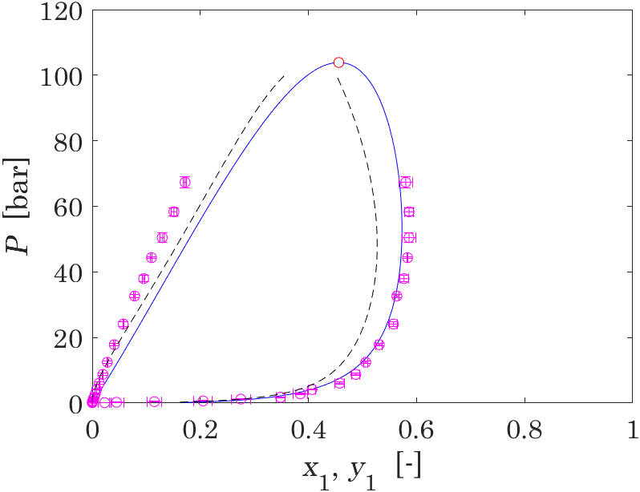

Figure 1. Figure caption, to be placed below the figure.

[Caption style: *Arial*, font size 10, centered text]

Table 1. Table caption, to be placed above the table.

[Table title style: *Arial*, font size 10, centered text]

|  |  |  |  |
| --- | --- | --- | --- |
| Case | Data 1 (unit) | Data 2 (unit) | Data 3 (unit) |
| 1 |  |  |  |
| 2 |  |  |  |
| 3 |  |  |  |

**Acknowledgment**

Use this section for the acknowledgment such as the supporting grants, etc.

[Acknowledgment style: *Arial*, font size 11, justified alignment, single line spacing]

**Significant references**

1. F. Pernechele, S. Bobbo, L. Fedele, and R. Stryjek, *Int. J. Thermophysics*, vol. 30 (2009), pp. 1144-1154.

2. M.J. Assael, A. Chatzimichailidis, K.D. Antoniadis, W.A. Wakeham, M.L. Huber, and H. Fukuyama, *High Temperatures–High Pressures*, vol. 46 (2017), pp. 391-416.

[Reference style: *Arial*, font size 11, justified alignment, single line spacing]

**[Please, remove all format instructions before submitting the abstract]**